Laboratory Assignment 5
On
Design Principles of Operating System
(CSE 3249)

Submitted by

Name : Dinanath Dash
Reg. No. : 2241004161
Semester : 5th
Branch : CSE
Section : 2241026
Session : 2024-2025
Admission Batch : 2022



DEPARTMENT OF COMPUTER SCIENCE & ENGINEERING
FACULTY OF ENGINEERING & TECHNOLOGY (ITER)
SIKSHA ‘O’ ANUSANDHAN DEEMED TO BE UNIVERSITY
BHUBANESWAR, ODISHA – 751030

Assignment 4: Familiarization with Process Management in Linux environment.
Objective of this Assignment:
- To trace the different states of a process during its execution
- To learn the use of different system calls such as (fork(),vfork(),wait(),execl()) for process handling in Unix/Linux environment.
- Producer-Consumer problem Problem:
Write a C program to implement the producer-consumer program where:
• Producer generates integers from 1 to 100.
• Consumer processes the numbers. Requirements:
• Use a shared buffer with a maximum size of 10.
• Use semaphores and mutex to ensure thread-safe access to the buffer.
• Print the number that producer is producing and consumer is consuming.
• Both producer and consumer will continue for 20 iterations
Output -
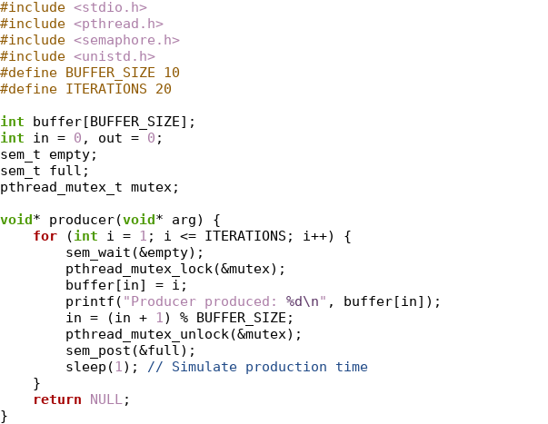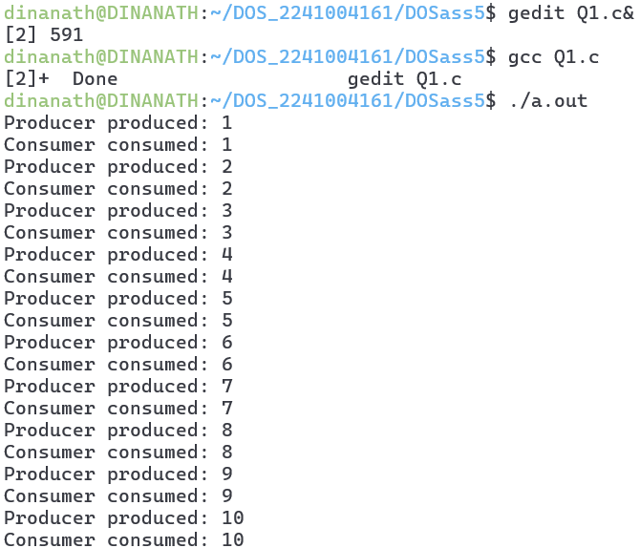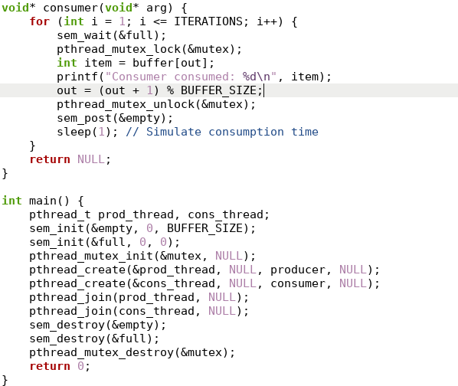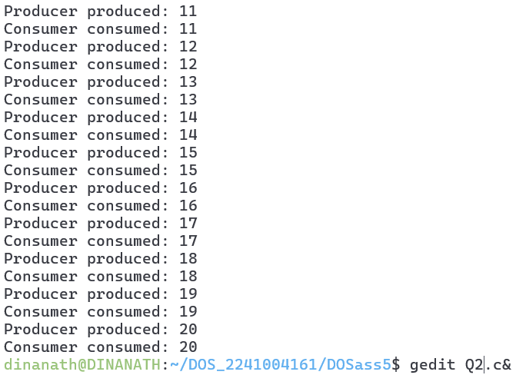

- Alternating Numbers with Two Threads Problem:
Write a program to print 1, 2, 3 … upto 20. Create threads where two threads print numbers alternately.
• Thread A prints odd numbers: 1, 3, 5 ...
• Thread B prints even numbers: 2, 4, 6 ...
Requirements:
• Use semaphores to control the order of execution of the threads.
• Ensure no race conditions occur.
Output-
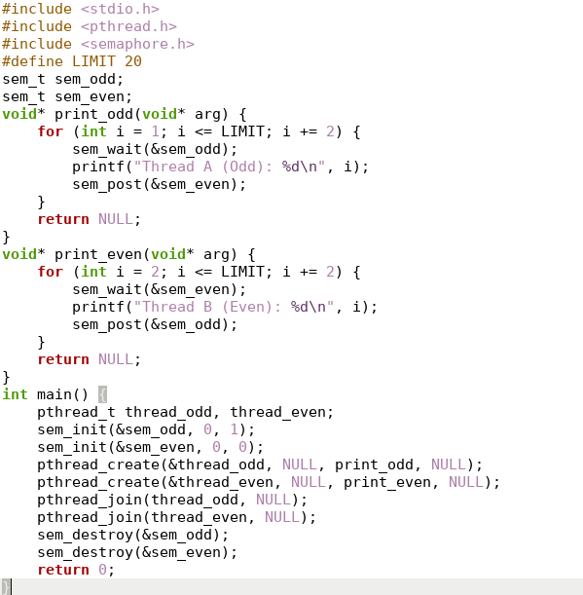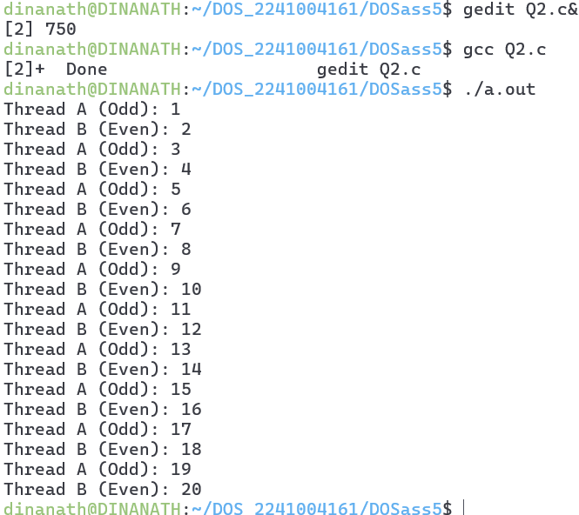
- Alternating Characters
Problem: Write a program to create two threads that print characters (A and B) alternately such as ABABABABA…. up to 20. Use semaphores to synchronize the threads.
• Thread A prints A.
• Thread B prints B.
Requirements:
• Use semaphores to control the order of execution of the threads.
• Ensure no race conditions occur.
Output-
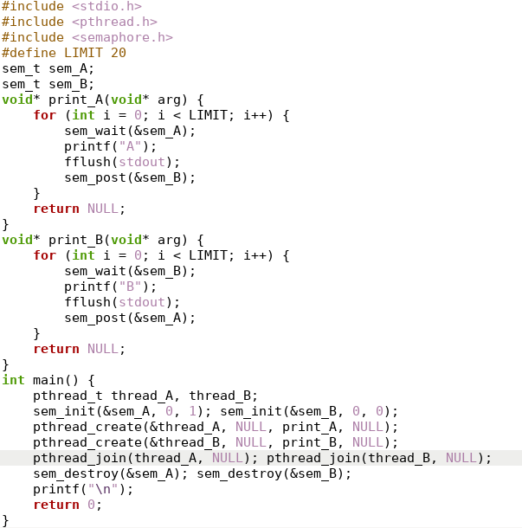
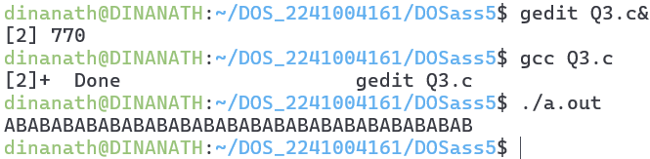

- Countdown and Countup
Problem: Write a program create two threads where:
• Thread A counts down from 10 to 1.
• Thread B counts up from 1 to 10.
Both threads should alternate execution. Requirements:
• Use semaphores to control the order of execution of the threads.
• Ensure no race conditions occur.
Output-
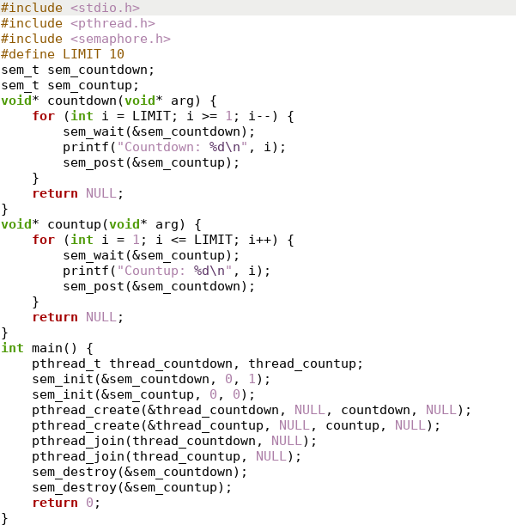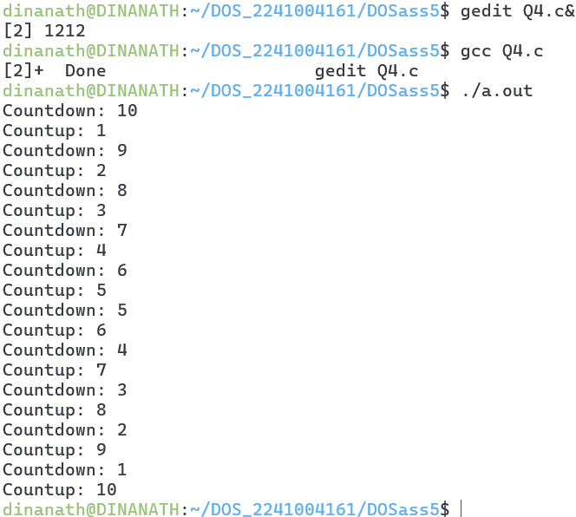

- Sequence Printing using Threads
Problem: Write a program that creates three threads: Thread A, Thread B, and Thread C. The threads must print numbers in the following sequence: A1, B2, C3, A4, B5, C6 … upto 20 numbers.
• Thread A prints A1, A4, A7, …
• Thread B prints B2, B5, B8, …
• Thread C prints C3, C6, C9, ...
Requirements:
• Use semaphores to control the order of execution of the threads.
• Ensure no race conditions occur.
Output-
